We take the two categories variables: Business Status, and Impact Started Business as our base categories, take the other five numeric variables: Revenue Increase, Capital Investment, Gross Revenue, and Total Employee, and New Job Created as our analysis objects. Our goals is to find the average trend of each metrics in terms of the company categories and In business Status and also to make the comparisons over all metrics in each different business categories, to determine the different effect level on consulting.

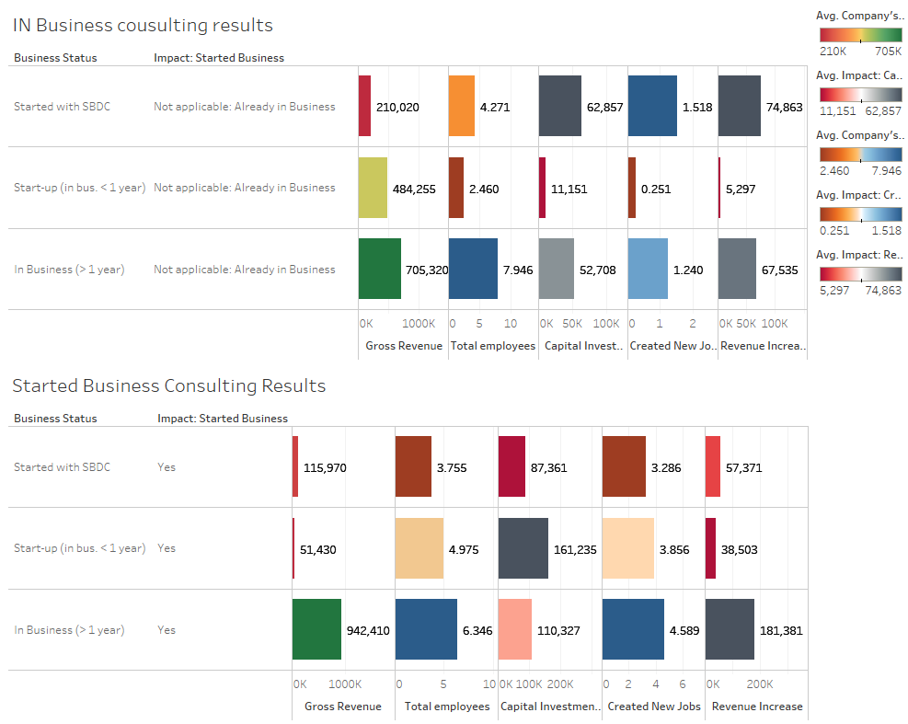

The companies who are already in business, The Business who are in business larger than 1 year secure the most capital investment and the most employees. However, for the companies who start-up with in 1 year, the consulting results are not as optimized as the other two. Especially for the company revenue increase and new job created. For the companies who started a business during the report time, the consulting results are still more significant on the companies who are in business larger than 1 year. Part of the reasons are those companies are in business for a time period, and they focus more on retain the revenue gross and employees instead of dragging more capital investment. SBDC should focus on the Gross Revenue and revenue increase more on those business who has been in industry for a while.

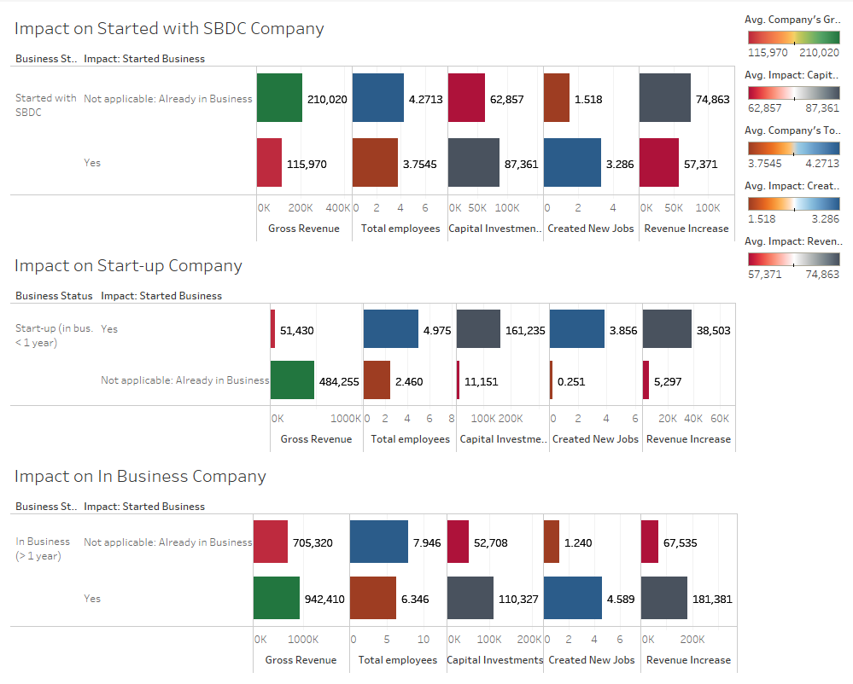

On the other hand, For the Company which started with SBDC, if the company started with the business at the same time, the consulting has an effect results on employees, capital investment and created New jobs and Revenue increase. However, for the company which starts less than 1 year, the consulting effects are insignificant on capital investment, creating new jobs and revenue increase.

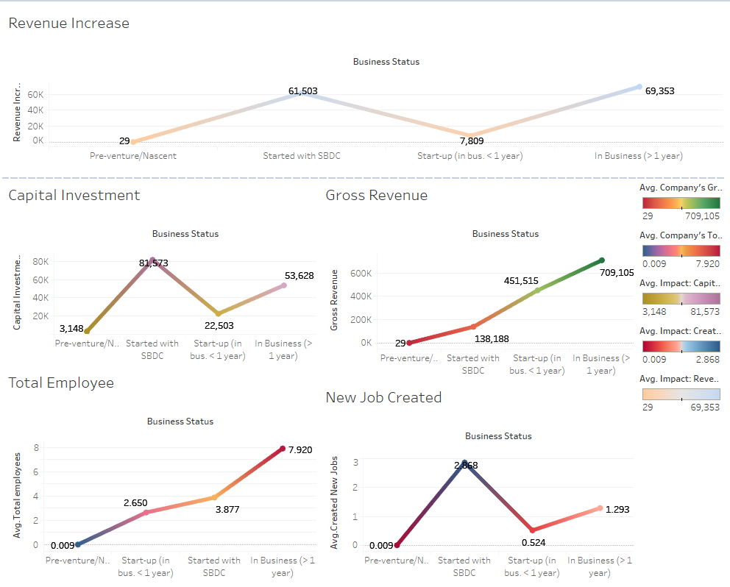

During the four type of business status, the start-up within one-year companies have a decreased amount in terms of Business Status, and Capital Investment. It turns out that company starts with SBDC even outperform than Business which are in business longer than 1 year in terms of capital investment and job created. It turns out that companies need a business consulting as earlier stage as possible which can potentially guide the business into correct direction.

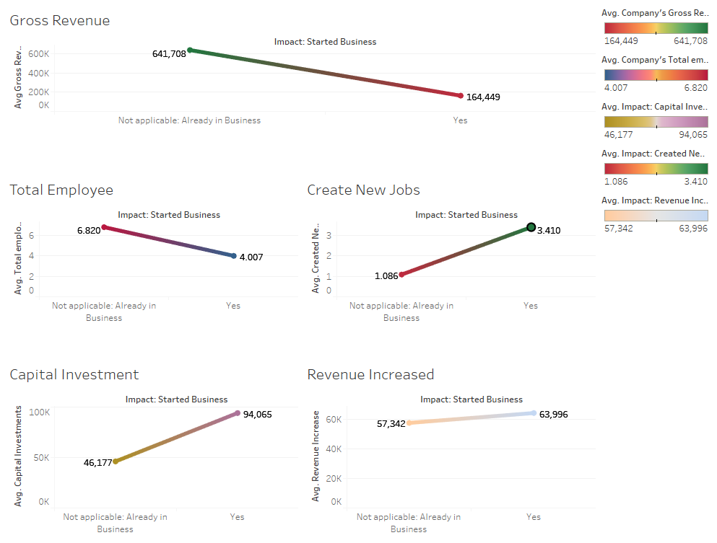

We also compared the companies already in business and companies start a business. We can see that the company started with a business during the reporting time tends to have higher on capital investment, revenue increased, and new job created. Among those, we can see the revenue increases is not very significant, it could be one of the questions for SBDC that what is the main target when consulting about the company profit? Does starting a business at beginning or at the middle of the business have different impact? Personally, For the sake of understanding more details about the relationships, SBDC needs to focus on other impact such as business owner, business location and so on.